* **Basic and approach**

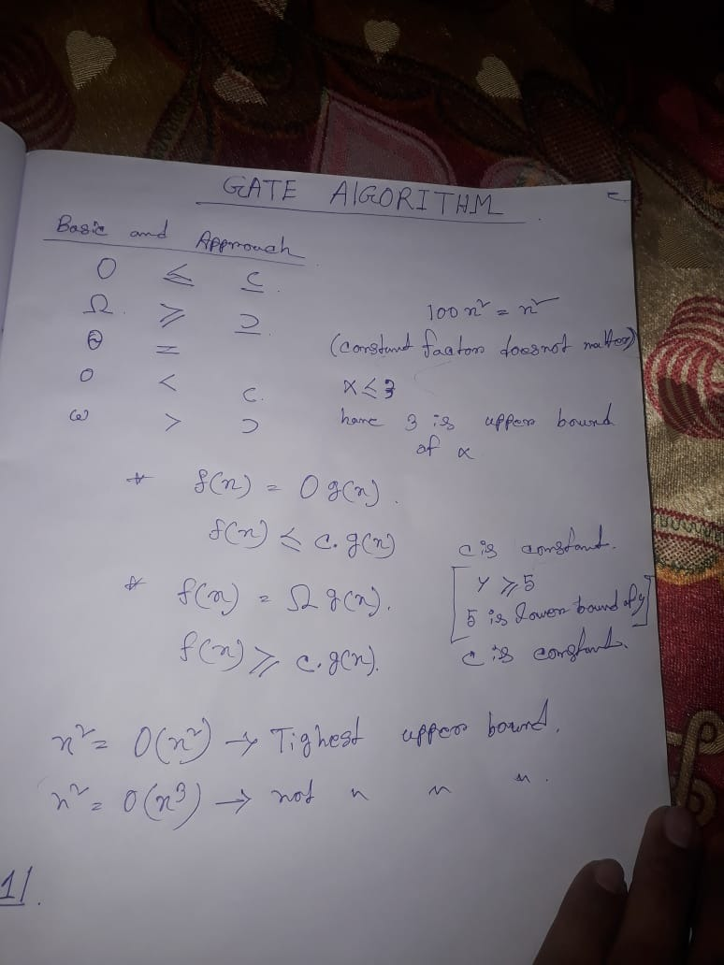

Constant<Linear<polynomial<exponential

100000< n < 2k < 2n [k is constant, n is linear value].

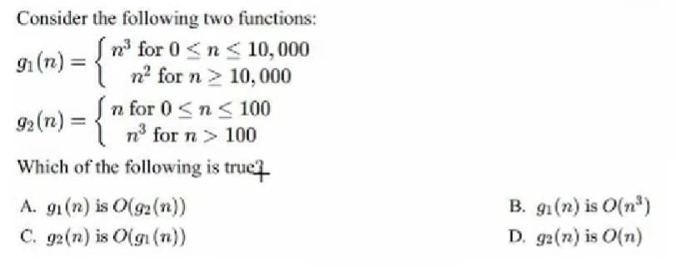

As we have to take upper value of n,

So, 



1. n2 <= n3 it is correct.
2. n <= n3 it is correct
3. n3<= n2 it is false.
4. n3 <= n it is false.

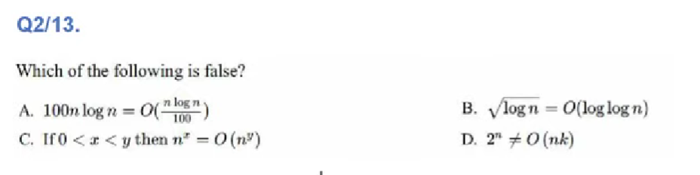

1. nlogn <= nlogn so it is true.

So , option B is false. 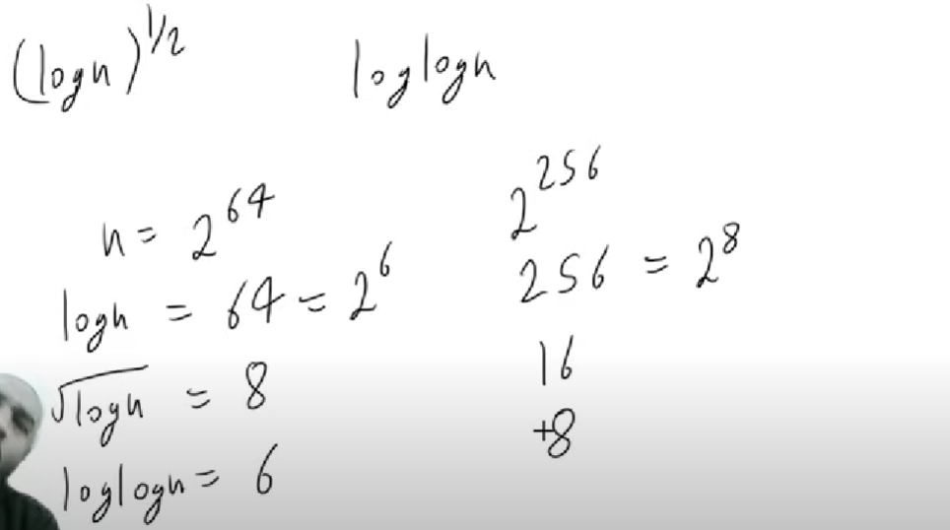

1. As y is greater than y, so it is also true.
2. Hare 2n is exponential but in nk , k is constant and n is linear,

So it is also true.

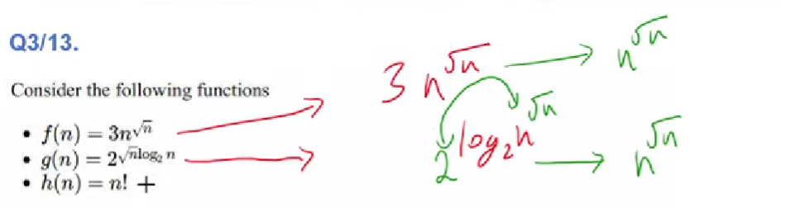

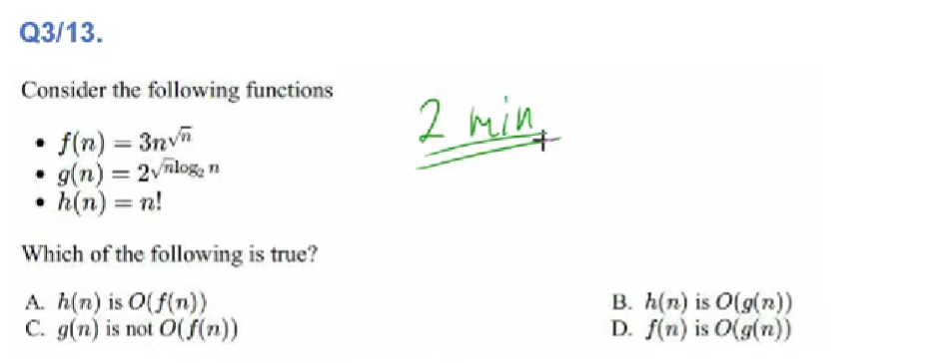

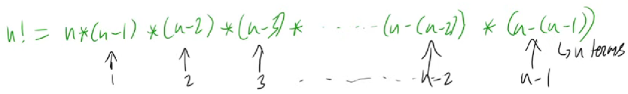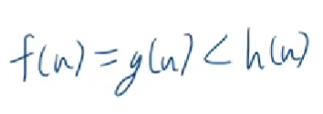

So, option D is only correct option.

**one important concept of taking log**

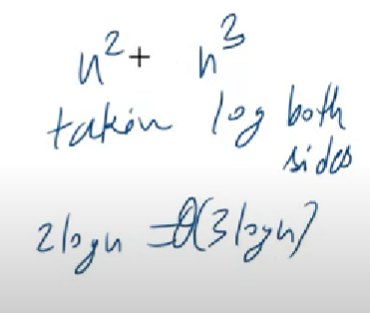 hare if I took log between them, it giving wrong ans.

Before taking log we should remove common part.



O(1) and O(n).

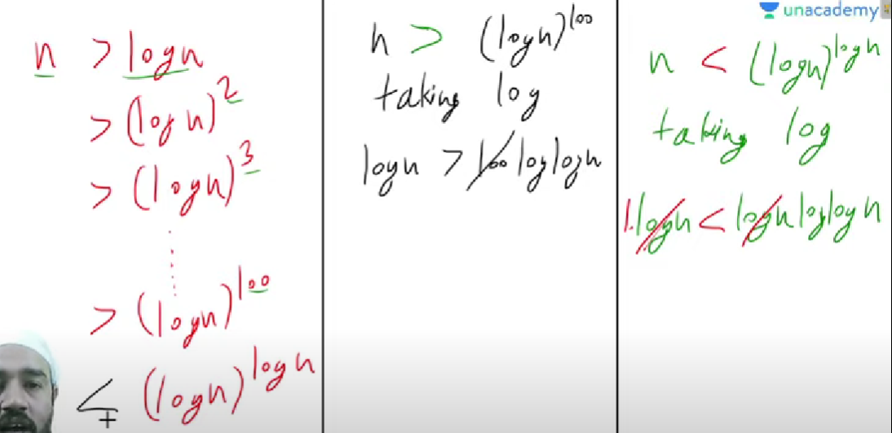

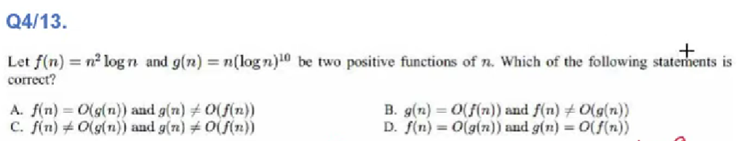

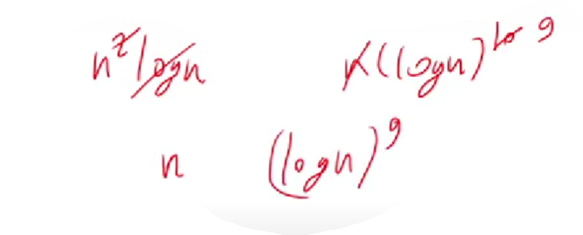

So, option B is correct.

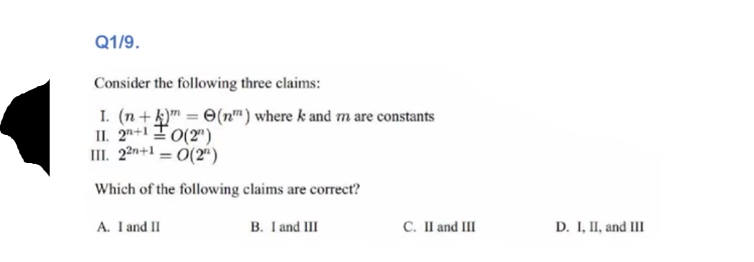

1. 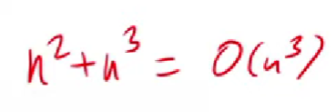(n+k)m = nm, so I is true.
2. 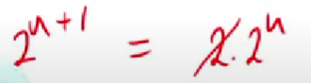 so II is also true.
3. 22n+1 = 2.(2n)2, so , III is false

Ans is A.

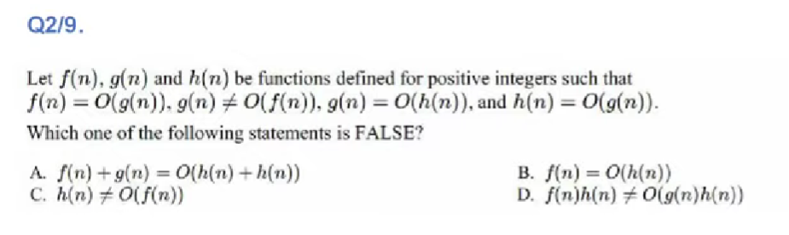

………………………………………………………………………….

f(n) = O(g(n)) 🡪 f(n) <= g(n)

g(n) != O(f(n)) 🡪 g(n) != f(n) and g(n) !< f(n)

……………………………………………………………………………

From this two we can get f(n) < g(n)

……………………………………………………………………………

g(n) = O(h(n) 🡪 g(n) <= h(n)

h(n) = O(g(n) 🡪 h(n) <= g(n)

…………………………………………………………………………..

From this two we can get g(n) = h(n)

1. f(n) + g(n) = O(h(n) + h(n))
   * f(n) + g(n) = g(n) .............as g(n) is greater
   * O(h(n) + h(n)) = O(2h(n)) = O(h(n))
   * So g(n) <= h(n) is true.
2. f(n) <= h(n) is true as g(n) = h(n).
3. h(n) > f(n) is is also true.
4. f(n)h(n) != O(g(n)h(n))
   1. if we eliminate both sides h(n) then,
   2. f(n) != O(g(n).................but it is false.

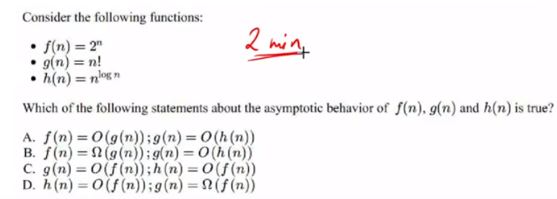

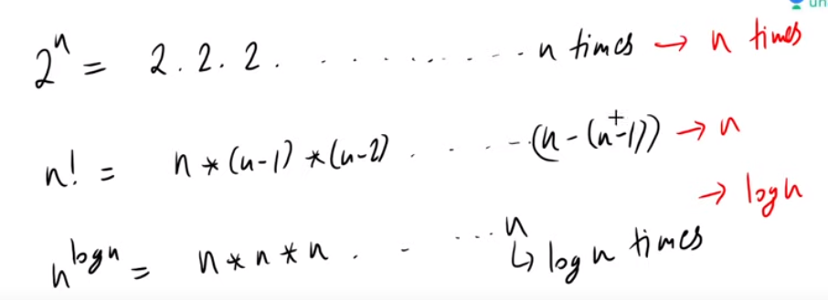

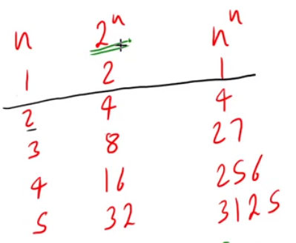

So, h(n) < f(n) < g(n). ......................So that option D is correct.

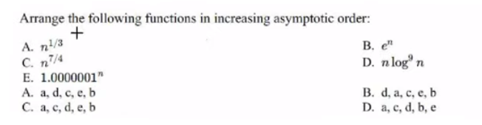

Let understand the concept of polynomial and exponential first.

Polynomial 🡪 variable to the power constant 🡪 n1000000000

Exponential🡪constant (or variable) to the power variable🡪 nn or 1000n

Exponential functions are much more greater than polynomial, no matter how much bigger than polynomial function is it, but even though it can’t challenges the exponential function.

1. Polynomial.
2. Exponential..........value of e is 2.718(approx)
3. Polynomial...........(n.n3/4)
4. Polynomial
5. Exponential.

* Out of B and E, B is greater.
* Out of A,C,D A is the smallest and n3/4 > log9n
* So, ans is A.

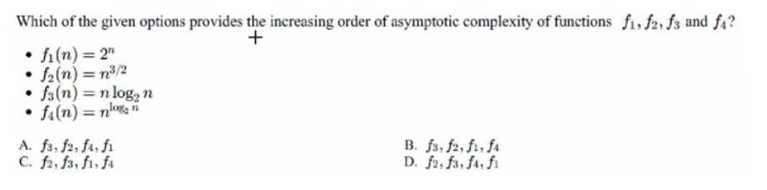

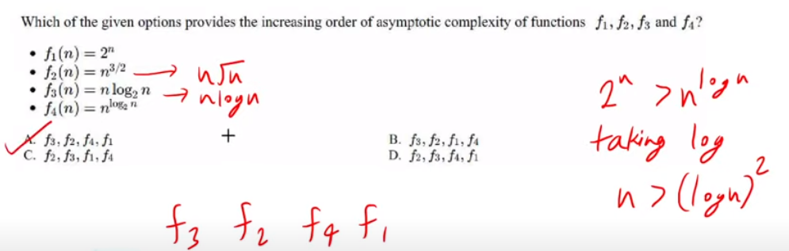

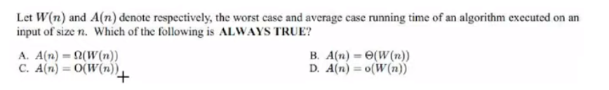

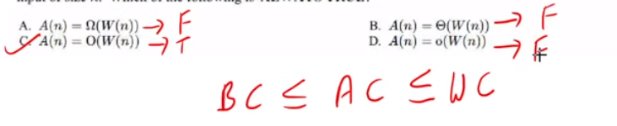

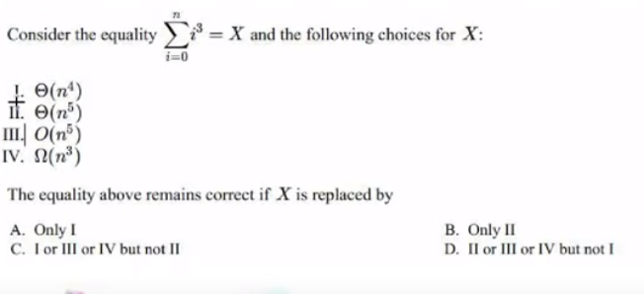

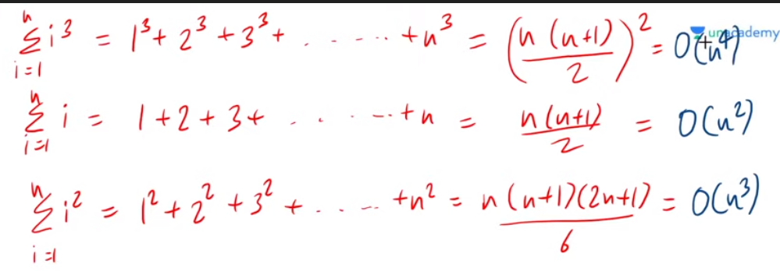

1. X = n4...........so I is true.
2. X = n5...........it is false.
3. X <= n5.........it is true.
4. X >= n3.........it is true.

So , the correct option in C.

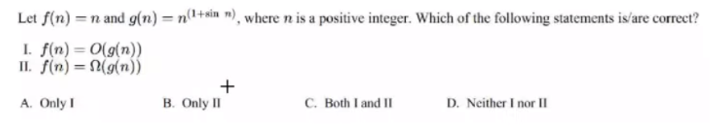

When sin(n) = -1 then f(n) > g(n)

And when sin(n) = 1 then f(n) < g(n)

So both option I and II are false.

So the ans is D.

